Chapter 1

1. Describe ERP

Enterprise Resource Planning is business process management software that manages and integrates a company’s financials, supply chain, operations, reporting, manufacturing, and human resources that enables you to run the core processes of a business.

This allows an organization to analyze transactional data, resulting in more steamlined processes and greater efficiency.

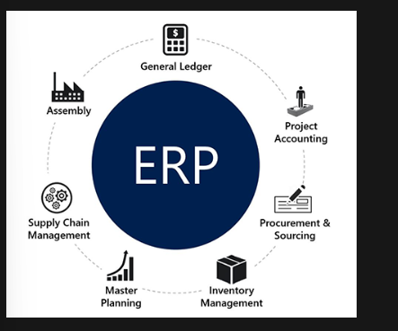

1. Introducing Dynamics 365

Is a set of intelligent business applications that work together seamlessly that provides CRM for marketing, customer services, field services, and sales through its customer engagement apps, where it connects with Microsoft Power Platform and Microsoft Dataverse

1. Financial and operations apps

* Finance: global financial management to monitor performance in real time
* Supply Chain Management: empowers employees and organizations with the ability to obtain a unified view of inventory
* Commerce: Delivers a comprehensive solutions that unifies tour back-office, in-store, call center and digital experiences.
* Human resource: Workforce insights you need to build data-driven employee experience
* Project operations: visibility, collaboration, and agility needed to drive success across the project centric business

1. Business Central

Automates and streamline business processes within areas such as finance, manufacturing, sales, shipping, project management, and services. It can be implemented for a single user, whereas finance and operations apps require minimum of 20 users for implementation.

1. Why use Financial and operations apps?

* Lack of capacity

Problem: Current system hasn’t kept up with you as company has grown and added more staff.

Solution: ERP allows your company to expand while the solution manages your company’s everyday business processes.

* Lack of insights

Problem: still uses software that works independently from other systems

Solution: Finance and operations apps offer data analytics and business insights by connecting all the disparate systems together

* An existing system that is costly to operate

Problem: you pay a lot to operate your current ERP deployment

Solution: it may be time for an even closer to decide if you should move to the cloud, keep things on-premise, or invest in a combination of both.

1. Discover what a modern ERP system can offer

* Increase productivity
* Get control of financial management
* Help with human resources management
* Streamline project management needs
* Improve supply chain and operations management
* Make better decisions by using business intelligence and artificial intelligence

1. Cloud vs on-premises implementation of finance and operations apps

|  |  |  |
| --- | --- | --- |
| Capability | Cloud | On-premises |
| Infrastructure and data location | * Cloud service managed by Microsoft * Datacenters managed by Microsoft | * Infrastructure managed by customer or partner * Disconnected datacenter * local data residency |
| Data trustee | * Microsoft | * Customer |
| Application Lifecycle Management (ALM) | * Managed by Microsoft * Customer Access ALM and telemetry using Dynamics 365 Lifecycle services | * Managed by customer or partner with cloud-based ALM and telemetry using Lifecycle Services |
| Cloud Capabilities | * High availability and disaster recovery included | * High availability and disaster recovery managed by customer or partner |

1. Describe the finance and operations apps user interfaces
2. Navigation pane

Leftmost pane that can access any page

* + Favorites: most frequently used
  + Recent: your recently opened pages are automatically saved under the recent menu
  + Workspaces: all the workspaces are available in finance and operations apps
  + Modules: can find all the modules, sub-menus, and pages under the modules menu

1. Navigation Bar

The uppermost title bar that displays the options

1. Company picker

Allows you to select a legal entity.

1. Show messages

All the system messages generated in finance and operations apps.

1. Settings

Has several features, such as user options, task recorder, mobile app, and personalize

1. User options

Set up user-specific configurations that consists of four tabs.

* + Visual

Can define the general color and size of all the interfaces of the finance and operation apps

* + Preferences

Define user-specific configurations, including location and language

* + - Startup: define which legal entity to open when finance and operations apps are opened
    - Language and country or region preferences: define your default country or region and the time zone in which you are working.
    - Miscellaneous: enable the document handling feature
    - Accessibility: ensures all page elements are in the tab sequence.
    - Task management: enable a task list on the default dashboard
  + Account

Depicts the user credentials along with the email provider and email ID of the user, that allows you to send email, also electronic signature.

* + Workflow

Can be associated with different business processes.

1. Task recorder

Allows user to record business processes for different use cases, including the following

* + Step by step guided tours of specific business processes in the application
  + Documentation of a business process as a Microsoft Word document that can optionally include screenshots
  + Regression test for a business process
  + Automatic playback of a business process in the application

Once the business processes are recorded, they can be saved in the following ways:

* + Save to this PC

As an .axtr file and uploaded in the business process modeler (BPM) that creates the test case for the business process.

* + Save to lifecycle services

Using Regressing Suite Automation Tool (RSAT) that facilitates regression testing and significantly reduces time and cost user acceptance test (UAT)

* + Export as Word document

As a Word Document

* + Save as developer recording

Generate as XML

1. Personalize

Make changes in the UI, including adding a field in a page, making a field mandatory, and moving the position of a field

1. Action pane

Control on a page, such as edit, new, and delete buttons

1. Filters
   * Quick filter: this is a filtering mechanism that appears above any list or grid and provides fast single-column filtering.
   * Filter pane: this is an inline pane that slides in form the left and contains multiple filter criteria that can be applied to the targeted content
   * Grid-column filter: enables to define conditions and perform single-column sorting by using a drop-dialog control that is opened from the grid column header
   * Advanced filter or sort: provides an advanced filter and sort capability based on multiple columns that appear in the options button in the action pane.
2. Workspaces

A one stop shop for specific activities

* + Providing 360-degree views of activities
  + Answering specific questions
  + Providing insights
  + Navigating by data
  + Providing direct access to tasks
  + Analytical workspaces

Include a set of reports that offer insights into standard business operations, like dashboards and differ from financial reports

1. Mobile workspaces

Enables to make business processes on mobile devices

* + Users can view, edit, and act on a business data even in offline
  + IT admins or developers can
    - Build and publish mobile workspaces that are tailored to an organization
    - Easily design mobile workspaces by using the point and click workspace designer
    - Optimize the offline capabilities of workspaces by using the business logic extensibility

Chapter 2

1. Describe how to use power BI to analyze data

* Is a business analytics service that delivers insights to enable fast, informed decisions, and harness data also turn it into actionable insights
* Connects to hundreds of data sources using standard connectors and to unlimited data sources using custom connectors
* Simplifies how you derive insight from transactional and observational data, and helps you create a data culture where employees make decisions based on facts, not opinion
* Helps you connect data and display it as visually immersive, captivated and interactive insights that allows to drill down and analyze financial and operational data.

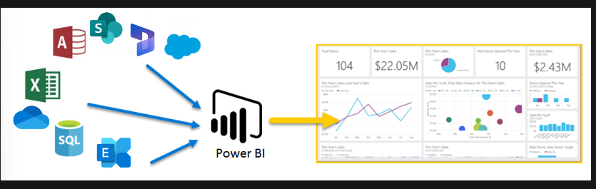

1. Filter data with power BI

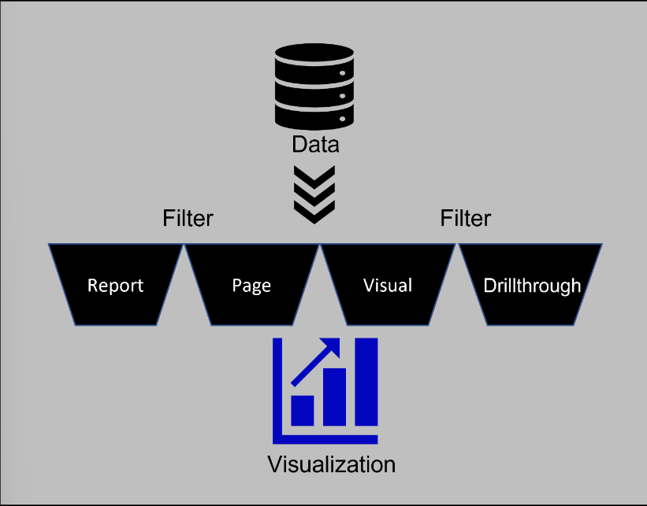

Explores the filter pane

* Report: applies to all pages in the report
* Page: Applies to all the visuals on the current report page
* Visual: applies to a single visual on a report page. You only see visual level filters if you have selected a visual on the report canvas
* Drill through: allows you to explore successively more detailed views within a single visual.

1. Transform data

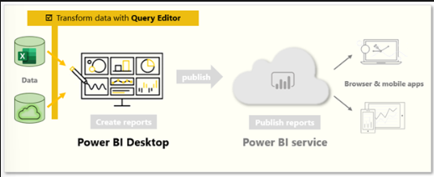

1. Microsoft Office

Common > Common > Office Integration > Document Templates

What is a data entity?

Is an object in a data model. Open data in Excel, you can:

* Open entity data in excel when you start from the finance and operations apps.
* Open entity data in excel when you start from excel
* View, edit, and update entity data in excel
* Add or remove columns
* Copy configuration data from one environment to another using a workbook.

Microsoft Word

To create a Word Template

* Navigate to Common – Common – Office Integration – Excel Workbook designer
* Select the required entity and the fields you want to display in the word template
* Select the create blank document button in the action pane once the field selection is complete
* The system prompts you to download the word template
* Navigate to common – common – office integration – document templates and upload the newly created word template

Share Point

Secure place to store, organize, and manage content, knowledge, and applications, which help the organizations

* Empower teamwork
* Quickly find information
* Seamlessly collaborate across the organization

Document Management using Share Point

Is a common framework in finance and operation apps that can be applicable for all the modules and pages that can associate a file or image with any record by selecting attachments icon by clicking organization administration – document management – document types

Email Integration

* Behaviors set by administrators
  + Batch email providers – Specifies which email provider the system uses to send emails that are generated by processes in a batch or non-interactive manner. The exchange provider uses the account associated with the batch process
  + Attachment size limit – specifies the maximum size of a single email that can be sent by using the email subsystem
* SMTP Settings tab
  + Outgoing mail server – the host name of the desired SMTP server
  + SMTP port number – Typically, the port number should be set to 587 for secure transport
  + username and password - specify as needed to send the email from the proper mail account
  + specify whether ssl is needed – determine whether secure transport is used

Email distributor batch process 🡪 is sent directly from the server, is sent by the email distributor batch process via SMTP

* behaviors set by users
  + Email provider selection selection on the options page
    - Email provider id – select the email provider that should be used when sending an email (user)
    - Sender email – provide an email address to override for the user in the from field of the email (administrator)

How would you like to send email dialog box?

* Use an email app, such as outlook (.eml file)
* Use exchange email server, uses the exchange online server associated with the tenant
* Use the system email client, opens the send email composition dialog box and then sends the resulting email via smtp
* Do not ask again – if the fields is not selected, the dialog box won’t open

Send email dialog box (optional)

* From – populated from the email field on the Options Page
* To, cc, Bcc, Subject and Body – Populated with values specified by the process that initiated the sending of the email
* Attachment list – may be populated with attachments specified by the process that initiated the sending of the email.

1. Explore business events integration capabilities

Business events can be triggered from finance and operations apps based on an activity, including triggering a workflow, confirming a purchase order, posting a journal, and creating, updating, or deleting an operation on a table (System Administration > Setup)

External application that can be used:

* Azure service Bus Queue
* Azure service Bus Topic
* Azure Event Grip
* Azure Event Hubs
* HTTPS
* Azure Blob Storage

Power Automate when a business event occurs

* Instance: Enter the finance and operations app environment URL
* Category: Select the business event category
* Business Event: Select the business event that you want power automate to consume
* Legal entity: Select the legal entity for which the trigger is applicable

Chapter 2: Learn the fundamental of Microsoft Dynamics 365 Finance

1. Describe Finance Capabilities and features
2. General ledger

Manage a legal entity’s financial records that register debit and credit entries where they are listed in a chart of accounts

1. Accounts receivable

The balance of funds due to a customer for products or services delivered and invoiced. It is used to track customer invoices and incoming payments

1. Accounts payable

The amount of money that a company owes its vendors or suppliers for goods or services that have been received but not yet paid for.

1. Cost Accounting

A branch of accounting that deals with the process of recording, classifying, analyzing, and summarizing the costs incurred by a business.

1. Budgeting

An overview of the budgeting functionality components, budgeting tools, and reporting capabilities that divided into three, that are budget planning, budget entry, and budget control.

1. Cash and bank management

Maintain the legal entity’s bank accounts and the financial instruments that are associated with those bank accounts.

1. Fixed assets

Are items of value that are owned by an individual or organization. The items include buildings, vehicles, land, and equipment.

1. Expense management

Create an integrated workflow to store payment method information, import credit card transactions, and track the money that employees spend.

1. Regulatory feature

Based on countries’ legal entity that can submits or reviews regulatory alerts

1. Asset leasing

Can capture and process the lease details and generate journal entries throughout the lifecycle of the lease, from initial recognition to monthly journal entries, to impairment, and termination of the lease.

1. Revenue recognition

Perform to allocate revenue (price is recognized based on the components) and defer revenue (contractual time frame and percentages for recognizing revenue over time).

1. Credit and collection management

Manage credit limits and control the flow of sales orders through the posting process

1. Describe organization and legal entities

Legal entity is an organization that has a registered or legislated legal structure

A company is a type of legal entity

Operating units: an organization that is used to divide the control of economic resources in a business

* A cost center is used for the management and operational control of business processes
* A business unit is used for financial reporting that is based on industries or product lines
* A value stream is commonly used in lean manufacturing to control the activities and production flows
* A department defines business operations based on functional areas.
* A commerce channel, which represents a brick and mortar store, an online store, or a call center.

Teams : A team is an organization in which the members share a common responsibility, interest, or objective

Organizational Hierarchy : Relationships between the organizations that drive the business operations

1. Describe number sequence functionality

Define the format of the identifier.

Scope: identify the components available in the segment sections

